

ENVIRONMENTAL POLICY
&
PROCEDURES MANUAL

Date of Issue: Oct 2025

Hillstreet UK Ltd
604 Warwick Road
West Midlands
B91 1AA
Tel: 0121 705 1106
Fax: 0121 7057080
Email: hillstreet@blueyonder.co.uk

Health & Safety Advisers: -

Hurst Setter & Associates Ltd
Unit 2, Barns Heath Farm
Snarestone Road
Appleby Magna
Swadlincote
DE12 7AJ

Tel: 01283 569625

Web: www.hurstsetter.co.uk
Email : safety@hurstsetter.co.uk

DOCUMENT STATUS

Issue No | Amendment – Update | Date Issued | Next Review | Completed By | Approved By
1 | Initial Issue | Feb 2022 | Oct 2022 | Darren Goble
2 | General Review – Brought in line with H&S Policy | Oct 2022 | Oct 2023 | Darren Goble
3 | Yearly review, Hurst Setter address change and links updated. Insert organogram chart. | Oct 2023 | Oct 2024 | Darren Goble
4 | General review and grammar/formatting check | Oct 2024 | Oct 2025 | Darren Goble
5 | Annual review, approved by column added to this table, minor changes only. | Oct 2025 | Oct 2026 | Darren Goble

The Owner of this policy is responsible for updating all non-legislative and regulatory sections.

Please note this Policy should not be populated throughout the company as a live document until it has been reviewed, approved and the above ‘Approved By’ section of this Document Status table signed off by a senior member of the Hillstreet UK Ltd management team, preferably the Managing Director.

Environmental Legal Register

Legislation | Guidance
Environment Act 2021 | https://www.legislation.gov.uk/ukpga/2021/30/contents/enacted
Environmental Protection Act 1990 | https://www.legislation.gov.uk/ukpga/1990/43/contents
Building Regulations. | https://www.gov.uk/guidance/building-regulations-and-approved-documents-index
Conservation of Habitats and Species Regulations. | https://www.legislation.gov.uk/uksi/2017/1012/regulation/17/made
Contaminated Land (England) Regulations. | https://www.legislation.gov.uk/uksi/2006/1380/contents/made
Control of Asbestos Regulations. | https://www.legislation.gov.uk/uksi/2012/632/contents/made
Control of Noise (Codes of Practice for Construction and Open Sites) (England) Order. | https://www.legislation.gov.uk/uksi/2015/227/made
Control of Substances Hazardous to Health Regulations. | https://www.legislation.gov.uk/uksi/2002/2677/regulation/7/made
Hazardous Waste (England and Wales) Regulations. | https://www.legislation.gov.uk/uksi/2016/336/contents/made
Waste (England and Wales) Regulations. | https://www.legislation.gov.uk/uksi/2011/988/contents/made
Waste Management Licensing Regulations. | https://www.legislation.gov.uk/uksi/1994/1056/contents/made
Controlled Waste Regulations 2012 | https://www.legislation.gov.uk/uksi/2012/811/contents/made

CONTENTS

1. DEFINITIONS & REGISTER OF ENVIRONMENTAL LEGISLATION 1
1.1 Definitions 1
1.2 UK Environmental Legislation 1

2. ENVIRONMENTAL MANAGEMENT SYSTEM 2

3. ENVIRONMENTAL POLICY STATEMENT 4

4. ENVIRONMENTAL MANAGEMENT ORGANISATION 5

5. DUTIES & RESPONSIBILITIES 6
5.1 Duties of the Director with Responsibility for Health, Safety & Environment 6
5.2 Duties of Directors and Other Senior Managers 6
5.3 Duties of Site Manager (and other persons in control of the site) 7
5.4 Duties of Supervisors, Engineers, Quantity Surveyors and Staff Visiting Site 7
5.5 Duties of Office Managers and Office Supervisors 8
5.6 Duties of All Site Staff and Operatives 8

6. SETTING OBJECTIVES AND TARGETS 9

7. MONITORING THE MANAGEMENT SYSTEM AND REVIEW 10

8. RECORDS 11

9. COMPETENCE TRAINING & AWARENESS 12
9.1 Company Employees 12
9.2 Induction Training 12

10. PLANNING - NEW CONTRACT PROCEDURES 13
10.1 Pre Contract Stage 13
10.2 Traffic Management Plan – Site Operations 14

11. ENVIRONMENTAL INCIDENT AND REPORT PROCEDURES 15
11.1 Definition of an Environmental Incident 15
11.2 Emergency Procedures 16
11.3 Reporting Procedure 16
11.4 Reporting an Environmental Incident 16

12. WORKING PROCEDURES 17
12.1 Dust 17
12.2 Fuels, Oils and Other Fluids Stored or Used on Site 17
12.3 Fume Emissions – Plant and Equipment 18
12.4 Noise Emissions 18
12.5 Vibration Levels 18
12.6 Hazardous Materials or Conditions during Demolition or Strip Out Operations 18
12.7 Hazardous Materials or Conditions during Civil Engineering Operations 19
12.8 Asbestos 19
12.9 Light Pollution 19
12.10 Management of Top Soil and Sub-Soil 19
12.11 Hedges and Trees 19
12.12 Wildlife Habitats 20
12.13 Waste Water and Ground Water 20
12.14 Waste Management (also See Section on Duty of Care) 20
12.15 Work On or Near Water Courses 20
12.16 Crushing & Recycling Operations 21

13. THE ENVIRONMENTAL PROTECTION (DUTY OF CARE) REGULATIONS 22
13.1 The Duty of Care 22
13.2 Hazardous Waste Regulations 2005 22
13.3 Duties of a Waste Producer or Consignor 23
13.4 Duties of a Registered Waste Carrier 23
13.5 Duties of the Waste Manager / Consignee 23
13.6 Duties on all Duty Holders 23
13.7 Completion of Site 24

14. SITE WASTE MANAGEMENT PLANS 25

15. TYPICAL PROCEDURES & BEST PRACTICE 26
15.1 Waste Hierarchy 26
15.2 Industry Guidance – Good Practice Guides 26
15.3 Aspects & Impacts Register – Typical Layout 27

Appendix 1 Environmental Inspection Report

Appendix 2 Environmental Incident Report Form

DEFINITIONS & REGISTER OF ENVIRONMENTAL LEGISLATION

Definitions
In environmental legislation and guidance we talk about Aspects and Impacts (in the same way in health and safety we talk about hazards and risk).

An ASPECT is something that has the potential to cause impact on the environment

An IMPACT is “any change to the environment (whether adverse or beneficial) wholly or partially resulting from an organisation’s activities.”

Therefore we must start by identifying ASPECTS – those activities which have the potential to cause changes to the environment.

Then we must assess how we can better plan and manage these aspects to eliminate or reduce the IMPACT they / we have the environment.

Environment – means both the built and natural environment in which we live. It includes:-
- Land
- Air
- Water
- Ecology – Flora & Fauna
- Natural resources
- Waste and waste disposal and or recycling
- Local community
- Heritage

ASPECTS & IMPACTS REGISTER - Whilst it is not a legal requirement to have an Aspects and Impacts register, if you are working towards ISO 14001 or already have a formal Environmental Management System in place, it is a necessity. The Aspects and Impacts register is one of the most useful documents to create when establishing an Environmental Management System as it will help to identify the potential impact of the company’s operations and determine what control measures need to be put into place to eliminate or reduce this impact. It is therefore important to spend sufficient time ensuring it is accurate and comprehensive.

UK Environmental Legislation
Legislation and guidance is continuously being updated and revised. For the latest legislation and guidance use the following web link to Environment Agency web page then click on relevant section for the latest and most up to date legislation and environment guidance.

England & Wales: https://www.gov.uk/government/organisations/environment-agency
Scotland: https://www.sepa.org.uk/regulations/
Northern Ireland: https://www.netregs.org.uk/legislation/northern-ireland-environmental-legislation/

ENVIRONMENTAL MANAGEMENT SYSTEM
The Managing Director accepts that he is ultimately responsible for the actions of the company under his control. However he clearly cannot be responsible for every aspect of Environmental Management; these duties will be delegated to others within the company structure. The organisation chart identifies the Environmental Management structure within the company and shows the way in which this promulgated throughout the company to senior managers.

With regards to driving Environmental Management forward there must be a strong commitment from all Directors and senior managers. The Managing Director has demonstrated this commitment through the company’s Environmental Policy & Operation Manual.

The diagram below illustrates the basic building blocks of a progressive ISO 14001 Environmental Management System. The company’s systems and procedures are based on this accepted standard.

Management
Review
Monitoring
Auditing and
Corrective Actions
Continual Improvement
Implementation and Operation
Planning
Management Commitment and Environmental Policy

This model is also referred to as the Plan Do Check Act model.

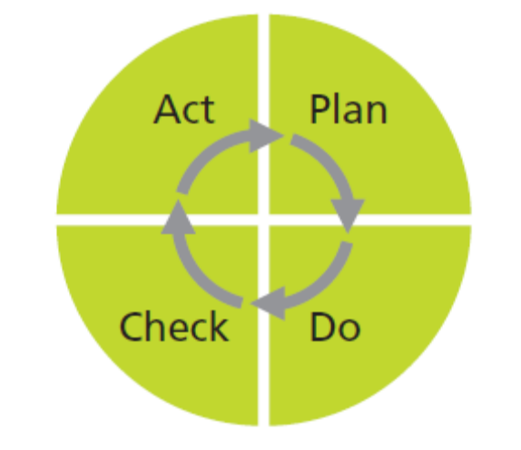

The tasks associated with each phase can be summarised as follow

Cycle stage | Management activities/steps | Relevant environmental management tool
Plan | - Identify priority issues (significant aspects)  - Establish/modify policy to address issues  - Identify performance standards/improvement opportunities (legal requirements, best practice solutions)  - Allocate specific responsibilities  - Set objectives and targets to meet performance levels  - Prepare action plans, programmes and procedures for achieving performance/meeting objectives and targets. | Environmental review (initial or subsequent)
Do | Those responsible implement plans, programmes and procedures Standards and procedures | Standards & procedures
Check | - Monitor results  - Evaluate performance against policy aims, objectives, targets, plans, programmes and procedures  - Determine reasons for deviations, e.g. non-conformances | Environmental monitoring & management audit
Act | - Take corrective action for non-conformances  - Consider performance and adequacy of system elements in delivering desired performance  - Ensure changing circumstances are identified  - Modify system elements: policy; objectives and targets; responsibilities; plans; programmes; procedures, as necessary | Management review

ENVIRONMENTAL POLICY STATEMENT
The company is committed to protecting the environment by complying with all relevant UK legislation, meeting national standards relating to the environment and in accordance with best working practices currently in use by the industry. This is an ongoing commitment which requires working procedures to be frequently reviewed and adapted to reflect the continual changes to ensure the company is at the forefront of the changes with regards to environmental protection.

The company uses the word environment to cover natural environment and ecosystems as well as the built environment and the effect the company’s operations can have on people’s lives and heritage. This pledge to environmental protection is further extended to protect the health & safety of employees and the public in general so that the company’s impact on people’s environment is beneficial and not harmful.

To achieve these objectives the company will:

- Fully comply with current legislation, our own company operating procedures and/or clients operating procedures to ensure the highest standards are obtained. The company is not satisfied with merely satisfying minimum legal requirements but will be proactive with its clients in setting and achieving higher standards when practicable.
- Ensure any sub-contractors working under the company’s control also follow similar standards and attitudes.
- Ensure company staff are aware of environmental issues and the procedures they must follow.
- Minimising the impact of the company’s activities by adopting best practices that are available at that time. This maxim will be applied to all aspects of the company’s activities including design, site operations, selection and use of plant & transport, energy efficiency, re-use and recycling options, and waste minimisation
- Ensure that adequate resources are made available to fully implement the objectives of this policy.

With regards to fixed location operations, the company will carry out an environmental impact assessment of the premises and activities and produce an action plan covering what changes can be made to reduce the effect.

With regards to site activities, environmental issues will be considered along with quality and health & safety issues at the planning stage and the environment impact assessment will be incorporated into the project health, safety & environmental plan and agreed with the client before work commences.

The environmental performance of the company is to be monitored by those nominated and will be reviewed annually by the Managing Director. Objectives will be set and the monitoring and review is to ensure the company is achieving these objectives. This review will also take into account changes in legislation, advances in technological knowledge and changes in industrial practice, and if required, the company’s objectives will be re-set taking into account these changes.

The company is aware of IS0 14001 and will adopt the philosophy detailed in these standards in its operations.

This environmental policy is approved by the Directors and will be subject to an ongoing annual review by the Safety, Health and Environmental Committee chaired by the Managing Director.

Original Signed & Dated by

Managing Director

ENVIRONMENTAL MANAGEMENT ORGANISATION

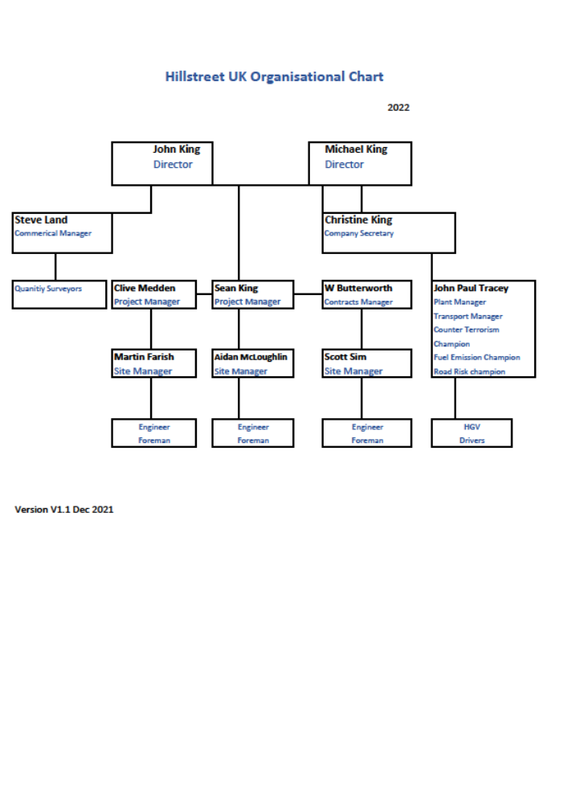

DUTIES & RESPONSIBILITIES

Duties of the Director with Responsibility for Health, Safety & Environment
In addition to his general director duties the HS&E director shall have additional responsibilities for:-
- Providing a Company statement on any issue of health, safety or environment that requires a formal statement.
- Ensuring he is informed of and agrees with any correspondence to/from the Environment Agency or other enforcing authorities.
- Having regular meetings with the Contracts Managers with a view to reviewing performance in the last period, setting objectives for the next period, and receiving feedback in general on environmental issues.
- Ensuring the Board is informed of any major environmental issues affecting or likely to affect the Company, and through the Board promote a pro-active approach on such issues.
- Ensuring there is adequate environmental advice and awareness at all levels of the Company; ensuring all employees are made aware of the Company’s Policy and they receive adequate training and consultation to enable them to contribute to minimising the Company’s impact on the environment.

Duties of Directors and Other Senior Managers
Directors and senior staff should implement the Policy by:

- Ensuring environmental issues are given consideration at the tender stage and that such issues are identified so that an effective control strategy can be developed.
- Ensuring staff and contractors at all levels receive appropriate training to enable them to understand environmental issues and the important role they play in minimising environmental impact.
- Monitoring environmental performance through site meetings and responding to actual site conditions observed when on routine site inspections.
- When holding meetings with employees and other people, ensure environmental issues are discussed and receive comments and suggestions on ways in which the Company’s performance can be improved.
- Setting a good personal example and having adequate knowledge of health, safety environmental legislation relating to your aspect of the Company’s work.

Duties of Site Manager (and other persons in control of the site)
The duties are to:

- Understand the Company Environmental Policy and ensure it is brought to the attention of all employees, particularly new starters, through induction talks.
- Have adequate knowledge of legal requirements and good working practices.
- Ensuring that all necessary registers and records are maintained and that persons under your control are adequately trained to enable them to understand their role in environmental issues.
- Ensure that the necessary environmental risk assessments have been carried out and recorded. The main findings of these assessments should be brought to the attention of the site staff along with the health & safety risk assessments.
- Ensure that adequate arrangements are made with regards to waste procedures to both minimise waste and to ensure waste is correctly classified and handled.
- In planning the site layout and work give due regard to environmental issues as identified in the assessment.
- Ensure any environmental incident is reported in accordance with Company policy.
- Set a good personal example at all times.

Duties of Supervisors, Engineers, Quantity Surveyors and Staff Visiting Site
The duties are to:

- Be familiar with the Company’s environmental policy and the legislation as it relates to your work.
- Ensure that you give concise instructions to operatives working under your control, detailing what precautions/actions must be taken to minimise environmental impact.
- Ensure that new employees, apprentices, young persons or occasional site workers are aware of the issues and what actions they must take.
- Set a good personal example.

Duties of Office Managers and Office Supervisors
Your duties are to:
- Understand the Company’s health, safety & environmental policy and ensure it is brought to the attention of all employees, particularly new employees and temporary employees, through induction talks.
- Have adequate knowledge of environmental requirements and practices as they relate to your work and that of the office. Assist and encourage staff to be more environmentally aware in the everyday workings of the office.
- Ensure any environmental incident is reported in accordance with Company policy.
- Set a good personal example at all times.

Duties of All Site Staff and Operatives
The Company has a strong commitment to health & safety and environmental issues. To be successful, the Company needs your assistance in following the Company’s procedures and so minimising risk. In addition the Company needs employees to be pro-active in these areas in identifying areas in which improvements can be made.

SETTING OBJECTIVES AND TARGETS
The Managing Director and SHE Committee carry out an annual review of all health, safety & environment procedures. Part of this review is to set objectives for the coming year. Included in the review will be:-

- Review last year’s performance in particular and incident reports, comments from enforcing authorities, comments from clients or their representatives, audit reports and critical site inspection reports.
- Review changes in legislation and assess the impact on company operations.
- With the appropriate Manager, review plant and transport needs and discuss any proposed changes.
- Set health, safety & environment objectives for the coming year.
- Taking into consideration the objectives that have been set, review staff awareness and produce training programme for the coming year.

MONITORING THE MANAGEMENT SYSTEM AND REVIEW
In any management system there must be an element of monitoring. If the system is not monitored and performance is not measured then it simply will not happen. Therefore the company has introduced the following monitoring regime

Each major project will have a health, safety & environment plan produced at tender stage and the pre contract issues described above will be considered. At contract award stage, the plan will be finalised to cover the construction phase.

The company’s safety advisers carry out routine site inspections monitoring the health and safety performance. This scope has been extended to also monitor environmental performance to selected larger sites.

The major review of environmental performance will be carried out annually by the Managing Director and the SH&E Committee.

RECORDS
Within the health, safety & environment plan will be details of any planning constraints or site discharge consents together with details of what project specific records will be kept. There are tremendous variations in the requirements for on-site monitoring of environmental issues such as noise, vibration, dust levels etc. Major city centre work tends to require greater degree of environmental monitoring and the contract documents will specify exactly what is required.

With regards to other records, the site manager will ensure copies of the following are held on site:-

- Transfer notes for controlled waste and consignment notes for any special wastes. At the end of the contract these must be returned to the manager who keeps all head office records relating to waste disposal and compliance.
- Copies of the companies and any other waste carrier’s registration license.
- A log book of complaints for neighbours, client’s representatives and others who may have reason to comment.
- Copies of any internal incident report forms and periodic environmental inspection reports.
- Copies of any on site environmental monitoring undertaken during a project.

COMPETENCE TRAINING & AWARENESS
The company has a strong commitment to training and this commitment will be extended to environmental issues. If the company is to progress and go forward on environmental issues its staff must understand the basic issues before they can contribute to changing procedures and improving performance. Therefore environmental issues will be included with health & safety project induction training, on the company training courses and refresher courses.

Company Employees
The Managing Director and SHE Committee will carry out an annual review of Environmental training needs and will produce an annual training programme for all levels of staff. In carrying out the review they will pay particular attention to persons whose role has changed, possibly due to a change in their scope of work, or possibly due to legislation changes. Employees taking on-board additional responsibility may need additional training. The training needs will be agreed by the board and budgets allocated. The Safety Director and Health & Safety Adviser will monitor that the training schedule is completed.

Induction Training
The manager (or his delegated representative) will carry out induction training for all new employees and temporary staff informing them of the significant environmental risks identified in the Health, Safety and Environmental Plan together with the emergency procedures.

Environmental Induction will cover:
- Office or site specific aspects & impacts and precautions to be taken.
- Energy saving initiatives and how they can assist
- Details of environmental emergency procedures.
- Waste segregation and waste disposal arrangements.
Confirmation of the induction talk will be recorded in the site diary or the induction register.

PLANNING - NEW CONTRACT PROCEDURES
Under the Construction (Design & Management) Regulations when the Company is taking the role of Principal Contractor for a project, a health & safety plan has to be produced identifying the significant hazards and detailing how the Company intends to manage that site so that the hazards are controlled.

This hazard identification will be extended to include environmental issues. The Contracts Manager and the Site manager will review the potential environmental impact of the project on both the natural environment and the built environment. Works will be planned to minimise the impact on both sectors.

Pre Contract Stage
At the pre contact stage the contracts manager should consider the following environmental aspects and ensure resources are allocated to eliminating or adequately controlling these issues. These are:-

Land Hazards  Contaminated ground  Abandoned substances  Silt or other run off  Dust | Water Run Off  Contaminated water  High colour  High suspended solids (silt)  High BOD or COD
Emissions into the atmosphere  Smoke  Fumes  Vapour  Mists  Steam plumes  Noise | Storage arrangements  Fuel  Other fluids  Plant – static  Plant – mobile  Plant – repairs & failures
Specified harmful substances  VOC’s  Hydro carbons  HCF’s  Sealants  Refrigerants | Packaging  Recycle  Return to supplier  To waste disposal sites
Natural Environment – flora & fauna  Land based eco systems  Water based eco systems  Air based eco systems | Living Environment –  General appearance / impact on surroundings  Cleanliness, lights, noise, vibration dirt & dust,  Traffic movement

Traffic Management Plan – Site Operations
It is normal practice for a traffic plan to be introduced and part of the health and safety plan required by the CDM Regulations. This traffic plan is being extended to include environmental issues as well as health and safety.

A major impact on the living environment is related to traffic movement. With any significant project there usually is a major element of transport as materials are moved on / off site for use, recycling or disposal. The traffic impact can be minimised by selecting traffic routes to cause least disruption to the adjacent occupiers. In city centre locations, it is often essential to set up a holding location where wagons can be held and called to site as and when the site is ready to receive them.

On wet or muddy sites, wheel wash facilities or road cleaning arrangements will also feature in the traffic management plan.

ENVIRONMENTAL INCIDENT AND REPORT PROCEDURES

Definition of an Environmental Incident
There are no legal definitions of environmental incidents and so the Company has adopted the following definitions and categories:-

Emissions to the Atmosphere
Ozone depleting substances | Greater than 100 kg. or any complaints
Odours | Any complaints
Any toxic gas | Any unplanned release
Dust, smoke and aerosols | Any complaints
Breach of emission limits | All occurrences

Emissions to land
Spillages of hydrocarbons | 50 litres or more
Pesticides and herbicides | Any uncontrolled spillage run off or spray drift
Contaminated or polluted water | 500 litres or more
Chemicals | Any uncontrolled or accidental spillage
Unauthorised deposit of waste | Any occurrence
Breach of Duty of Care | Any occurrence

Unauthorised discharge to a Watercourse
Any unauthorised discharge to a watercourse must be reported to the Environment Agency via web reporting link.

Breach of any consented discharge limit
Unauthorised discharge or depositing of solids or liquids into water (i.e. Demolition waste falling into water, contaminated liquids or ground water being pumped to rivers or streams etc.) | Any occurrence
Any unauthorised or deliberate act of vandalism which resulted in substances used or stored on site causing damage to a water course. | Any occurrence
Breach of any National River Authority pollution incident categories. | Any occurrence.

Noise
Breach of any regulatory limit or limits set by planning consent | Any occurrence
Any complaints of noise due to out-of-hours activities | Any occurrence

Emergency Procedures
Within the project specific health, safety & environment plan will be the emergency procedures for that project. These will reflect the local hazards and local environment. However on every project there must be spill containment arrangements so that if a fuel spill or other similar situation arises, the spill can be contained, the affected area isolated and the effected material properly recovered and disposed.

Any spill involving more than 25 litres of liquid must be classed as a major spill and reported as an environmental incident – see Incident reporting section for details.

Reporting Procedure
If an incident does occur on a company controlled site or due to company activities, the site manager should complete the environmental incident report form and submit it to the SHE Manager as soon as possible and at least within 24 hours of the incident occurring. See appendices for environmental incident report form.

Reporting an Environmental Incident

In the event of a significant spill contact the Environment Agency Incident Hotline Telephone
0800 80 70 60

WORKING PROCEDURES

General Site Dust – Emissions to Atmosphere
With any building or demolition work there is always a risk of dust being produced. This must be eliminated whenever possible by using the best method dust suppression to produce least environmental impact. If the production of dust cannot be eliminated, it must be controlled. Typical control measure includes a combination of the following:

- Carrying out as much work as possible with the dust contained in the building.
- Using sheeting to screen and contain any dust within the curtilage.
- Using water sprays to damp down any dust.
- Use vacuum systems to clearway dust and minimise dust production.

If the dust has the potential to contain hazardous substances such as silica (from some concrete aggregates) the protection of the employees must also be considered as well as protection to the environment.

Fuels, Oils and Other Fluids Stored or Used on Site
The storage area should be chosen having taken into consideration the environmental factors surrounding the site. If there are water courses or open drains, tanks should be positioned as far away as possible to minimise to potential for any spillage to enter such areas.

Diesel and fuel tanks will be bunded and the bund capable of holding 110% of the largest tank capacity. The bund will be fitted with a drain valve to allow rain water to be drained away. This drain valve should normally be locked shut and only used to drain away clean water under strict supervision

As an alternative, a purpose designed double-skinned storage tank can be used.

The discharge hoses should be kept in good condition and inspected on a weekly basis. The discharge nozzle should have a holding bracket to eliminate repeated small discharges after plant and vehicles have been re-fuelled. The discharge line should have an isolating valve positioned as close as possible to the tank and this discharge valve should be locked closed whenever the tank is unattended.

If possible, a hard standing should be provided for the re-fuelling area. When re-fuelling static plant and equipment, absorbent mats or granules should be available to deal with any spillage and drip trays should be used under such plant. Fuel being transported or carried around the site should be in purpose designed bowsers or carrying containers.

With regards to oils and other fluids, consideration will have to be given to health and safety aspects of these substances as well as environmental aspects. If it is safe to do so, they should be stored in a secure container where they are protected from vandalism and any spillages are contained within the container. With some substances, it is essential they are stored in open, well-ventilated areas in which case, bunding or other impermeable layer is placed under the storage area.

Fume Emissions – Plant and Equipment
The supply company should ensure that plant sent to site is in good condition and filled with the correct grade of fuel and lubricants. It is important that site manager’s ensure the daily checks are carried out and that the correct grade of fuel is used in the plant. If the Site Manager is not satisfied with the condition of the plant on arrival to site, he should reject the plant and demand better quality from the plant suppliers. The plant supply company should arrange for the routine servicing to be carried out. If the plant’s performance starts to deteriorate, and exhaust fumes and smoke are clearly visible, the Site manager should stop the plant and arrange the corrective action to be taken.

Noise Emissions
Consideration must be given to the noise levels that will be produced from the plant, equipment and site activities. Hired plant and equipment should be selected with noise levels in mind. If the plant has to be left running overnight, it is important that quiet plant or silence plant is used.

If operations involving high noise levels have to take place, consideration should be given to the people in the immediate vicinity and such works should be limited to the times which will have least impact on the neighbourhood. Noisy operations should be suspended at times such as morning breaks and lunch break periods.

Vibration Levels
When selecting plant and methods of demolition or construction; consideration must be given to the likely vibration levels and the effect on adjacent properties and operations. If the contract specifies vibration levels, then obviously these must not be exceeded. If no standards are set, vibration levels should still be considered and the guidance contained in BS 5228 Part 4 relating to Piling operations is relevant and can be used as guidance for other building and demolition operations.

Hazardous Materials or Conditions during Demolition or Strip Out Operations
In demolition or strip out operations, it is common to find a building or process that contains a number of potential hazardous substances with little or no information of the substance. Therefore a site investigation and assessment has to be carried out. Some typical areas of concern include:

- Water tanks still containing liquids.
- Other tanks, sumps, pits and pipework containing unknown products.
- Old engines and mechanical plant.
- Old electrical transformers and capacitors (potential hazard of PCB’s).
- Fire extinguishing systems containing halons.
- Air conditioning units of fridges/cold rooms (containing ammonia or other refrigerants).
- Battery banks for UPS power system back-ups.
- Old telephone switching and back-up systems.
- Large quantities of fluorescent and other light bulbs.
- Large quantities of smoke detectors
- Large quantities of luminous materials.
- Building infested by bird droppings, rats, mice etc.
- Buildings that have been occupied and used for illegal uses such as drug users. These can easily be contaminated with human excrement and other body fluids as well as discarded syringes and needles.

Hazardous Materials or Conditions during Civil Engineering Operations
Dust in general and dust containing silica. Depending on the type of aggregate used in the concrete dust from cutting and breaking could contain significant levels of silica.

Contaminated ground - the Client or Principal Designer should provide details of any known contaminants. If contaminated ground is uncovered, work should cease until the principal contractor and planning supervisor have been advised and the ground analysed and the contaminants identified. Specific assessments will then have to be carried out on how to handle the material.

Contaminated water - this could be standing water found in tanks, pits or excavations. It must be remembered that water with a high suspended solid content (muddy water) could still be classed as a pollutant depending on where the water is being discharged.

Asbestos
With any refurbishment, strip out or demolition work there is always the hazard of finding asbestos containing materials. The company’s health and safety policy requires enquiries to be made at tender stage including asking the Client or Principal Designer abut a full refurbishment type of asbestos survey together with the removal of any known asbestos containing materials together with a ‘Safe to Occupy’ certification form a recognised asbestos analyst company before the company starts work in that area.

The company has a policy of not allowing its own employees or subcontractors to work with asbestos containing materials.

Light Pollution
In some locations, light pollution from site lighting left on overnight can be a problem. Site managers should be aware of this potential nuisance factor when planning sites. Consideration should be given to neighbouring properties when positioning security and flood lights.

Management of Top Soil and Sub-Soil
In planning the site, the Site manager will take into consideration, the need to segregate stripped top soil from sub-soil and from other material. If the top soil is to be stored for a considerable period of time, intermediate action may be needed to keep the top soil in good condition.

Hedges and Trees
In general terms, all hedges and trees (and their roots) should be protected (if necessary, by fixed fencing) to ensure plant and site operations do not cause damage. Materials must not be stored under the area occupied by the canopy of the tree or hedge.

Wildlife Habitats
The contract documentation will generally identify any special wildlife habitats and the precautions that the Company has to take. If a previously unknown wildlife habitat is found, this should be identified to the client and a course of action agreed.

Waste Water and Ground Water
Waste waters from the canteen and welfare facilities must be discharged to a normal main sewer system or to a storage tank for removal by septic tank service.

Ground water that forms in excavations could be classed as contaminated. The contamination could be due to substances leaching out of the surrounding materials or it could merely be due to high suspended solids content of the water. If this type of water were to be discharged into an open water course, it could result in fish losses and damage to that water course ecology. Site managers should take this into consideration when pumping out excavations, sumps pits etc. and generally planning the site.

All discharges of water into water courses shall be subject to Environment Agency approvals. These approvals may have conditions relating to suspended solids and rate of discharge to avoid bank erosion and scouring.

Waste Management (also See Section on Duty of Care)
With regards to the office environment, it is the responsibility of the office manager to try and eliminate waste by better use of resources and by re-using items before resorting to disposal. Recycling of waste, such as waste paper, is preferable to disposal.

With regards to site operations, it is the site manager’s responsibility to develop a waste management plan for the project, taking into the consideration the type and quantities of waste that are likely to be produced. If special waste will be produced, waste removal; contractors should be vetted to ensure they have the necessary registration and approvals for handling such waste.

With regards to consignment notes, see the section on Duty of Care for further details.

Work On or Near Water Courses
If work has to take place on or near to a water course, a method statement will be required detailing the scope of work and the precautions that have to be taken to minimise risk to health, safety and environmental damage.

The method statement should also give details of emergency or out-of-hours arrangements so that someone from the site can be contacted should an emergency situation develop. These people should have received specific instructions on the action to be taken to minimise environmental impact should an incident occur.

Crushing & Recycling Operations
As part of our commitment to recycling and to limit the impact on the world’s resources, whenever possible material such as concrete and masonry waste should be used for recycling

If on site crushing is permitted and the quantities involved make this economically as well as environmentally viable, we can use the services of a mobile crusher and recycle company to ensure any materials that can be re cycle are re cycled.

THE ENVIRONMENTAL PROTECTION (DUTY OF CARE) REGULATIONS
Anyone who “imports, produces, carries, keeps, treats or disposes of any controlled waste, or a broker who has control of such waste” is subject to the Duty of Care.

Controlled waste is defined as any household, commercial or industrial waste, including building and demolition waste. Therefore any waste that leaves site is defined as controlled waste and must only be moved after a transfer note has been issued and it must be transported by a registered waste carrier.

The Duty of Care
The duty of care is described in the Environmental Protection Act 1990 which states that all those subject to the Duty of Care must:

- Prevent others from depositing, storing, treating or otherwise disposing of waste without a valid licence or contravene the licence conditions; or act in a manner likely to cause environmental pollution or harm to human health.
- Prevent the waste from escaping.
- Ensure that waste is only transferred to an authorised person / registered waste carrier.
- Include with the waste transfer note / HWCN a written description sufficient to enable others to comply with the duty and avoid committing an offence under this Act.
- This duty has been further extended by the Hazardous Waste Regulations 2005.

Hazardous Waste Regulations 2005
The regulations apply controls on movements of hazardous waste which is defined in Hazardous Waste List – The List of Wastes Regulations. The regulations details the categories of waste together with the recognised code number to be used to described the waste.

Hazardous waste can only be moved under the control of a hazardous waste consignment note system - see following link for Environment Agency HWCN01v111 and guidance on how to use HWCN system and the required registrations.

http://www.environment-agency.gov.uk/business/topics/waste/32196.aspx

HWCN has 3 copies (typically White – producers or consignors copy: Gold – carriers copy; Pink – consignees copy). The waste producer must complete Parts A B and D. The waste Carrier must complete Part C and give one copy (White copy) to the waste producer or Consignee, taking the other 2 copies with them.

The waste carrier hands the HWCN to the consignee who completes Part E confirming the waste as described has been successfully transported to their care (for disposal). They hand one copy (gold copy) to the waste carrier for their records and retain 1 copy (pink copy) for their records.

Duties of a Waste Producer or Consignor
A waste producer is responsible for providing an accurate description of the waste. This should include:

- The type of premises or business from which the waste is generated.
- The process that produces the waste and the quantity of waste.
- The name of substances which comprise the waste including a physical and chemical analysis, if applicable.
- The packaging of the waste to prevent its escape during transfer.
- Using a registered (or exempt) carrier to transport the waste.
- The waste disposer should report suspicious circumstances which may indicate a breach of the duty in the disposal chain to the waste regulations authority.

Duties of a Registered Waste Carrier
The Waste Carrier is responsible for:

- The adequacy of packaging and security of the waste whilst under his control.
- Ensuring that a description accompanies the waste and that this description is accurate.
- Ensuring that any alteration to the waste is recorded in the description of the waste.

Duties of the Waste Manager / Consignee
The Waste Manager or Consignee is responsible for:

- Checking the description of the waste they receive is the same as described on the HWCN. Sample checks on the composition are considered to be “good practice” and should be implemented.
- Carrying out the disposal operation in accordance with their legal and license requirements / conditions.
- Ensuring that correctly completed reports are submitted to the Environment Agency as and when required in accordance with their licence conditions.

Duties on all Duty Holders
All duty holders should look out for breaches of the duty committed by others in the chain. Breaches of the duty should be reported to the Environment Agency and further dealings with the offenders should be reconsidered.

Duty holders are only expected to do what is “reasonable in the circumstances.” The extent to which they should check up on others in the chain depends on the nature of the waste, how it is to be dealt with and what the holder might “reasonably be expected to know or foresee.” It is, for example, more important to check up on a consignment of toxic chemical waste than a load of waste paper.

Completion of Site
On completion of the site, all Waste Transfer Notes and Hazardous Waste Consignment Notes should be archived with the contract papers and must retained:

- For a period of 2 years in the case of transfer notes.
- For a period of 3 years in the case of hazardous waste consignment notes.
The Environment Agency could audit the Company at any time and they will expect to see records in accordance with these time scales.

SITE WASTE MANAGEMENT PLANS
Site Waste Management Plans Regulations 2008 were removed form UK legislation on 1st December 2013.

However the company will continue to produce and use site waste management plans on its larger contracts as a means of measuring controlling and reducing waste. This is in keeping with the company’s overall environmental objectives.

TYPICAL PROCEDURES & BEST PRACTICE

Waste Hierarchy
The principles of good environmental practice with regard to eliminating or controlling waste can be summarised by the following diagram.

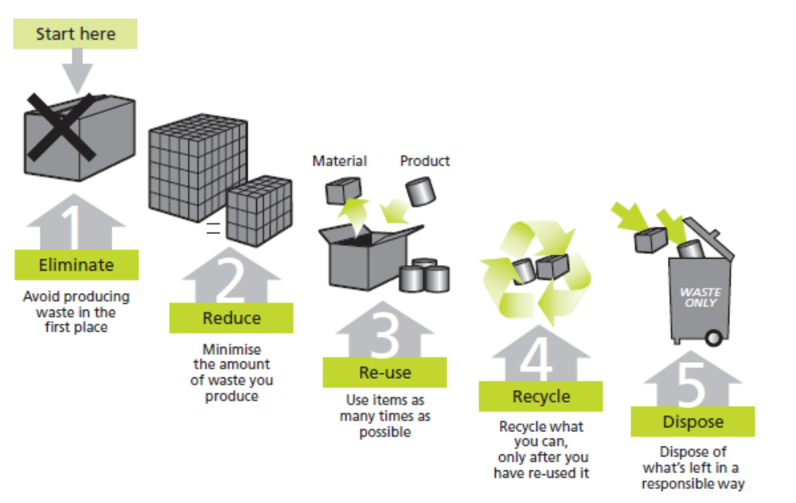

Industry Guidance – Good Practice Guides
Until recently, government environmental agencies have produced and issued formal Pollution Prevention Guidance known as PPG guidance documents. In general terms these have been withdrawn, subject to a further high level review. The following guidance has been retained:-

- PPG 21 – Incident Response Planning
- PPG 22 - Dealing with spills
- ‘Is Your Site Right?’ – a 10 Point Environment Agency Checklist
It is now down the client undertaking the project, in partnership with the principal designer and principal contractor to formulate and manage the necessary environmental safeguards appropriate to the project. This approach allows much greater freedom for the project team to focus on the environmental issues most relevant to the project.

The PPG series of guidelines did provide very useful guidance and because of this usefulness, it has been retained / is still available as an archive. The following guidelines are particular relevant to most construction sites and so have been downloaded by the company and form the basis of our environmental guidance to staff and project managers.

- PPG 1 – Understanding your environmental responsibilities
- PPG 5 – Working near a watercourse
- PPG 6 – Construction site guidance
The guidelines should be used to assist in assessing and establishing the environmental management system for the project. The starting point has to be a project environmental assessment identifying relevant aspects and impacts and producing a project Aspects / Impacts Register.

Guidance on compiling an Aspects & Impacts Register is given below. You will see it is very similar to undertake as H&S risk assessments. If you are unsure of the control measures to be applied to control or reduce the impact, use the guidance PPG 6 – Construction Site Guidelines.

Aspects & Impacts Register – Typical Layout
Before you start to evaluate your Aspects and Impacts will need to be identified. Refer to Environment Agency guidance PPG 1 – ‘Understanding Your Environmental Legal Responsibilities’ for more information.

Once you undertake the environmental review, you will produce a list of Aspects and Impacts. You now need to assess and prioritise the Aspects and this should be done before control measures are applied. This is the same as when undertaking an H&S risk assessment - you first identify the significant hazardous tasks or operations. With an environmental management system, identify the significant Aspects.

The consider industry guidance and good practice principles and apply the control measures that will be applied to this aspect. Once the control measures are applied evaluate the likely or typical Impact of this Aspect with the control measures applied.

Records your findings in the same way we record an H&S risk assessment – a typical proforma is shown below.

Establishing an Aspect / Impact Register - For each significant Aspect consider the likelihood or probability of an incident occurring; and if such an incident did occur, what would be the (typical) severity of the outcome.

Rating Allocated | Probability or likelihood of incident occurring  IMPACT probability |  | Seriousness or severity of the incident / outcome  IMPACT severity
1 | Unlikely or very low |  | Little or no impact
2 | Possible – will occur at some time |  | Some impact but impact will be controllable and easy to rectify with no lasting effects
3 | It will or Probably will occur unless control measures are applied. |  | Serious impact with lasting effects– unacceptable

By using a 3 x 3 matrix rating system, the significance of each aspect can be impact rated as follows:-

Significance or Impact Rating = Likelihood rating x severity rating

So for example and aspect that ‘probably will occur’ (Probability rating 3) with a severity rating of ‘some impact but no lasting effects’ (severity rating 2); gives a Significance or Impact rating of 3 x 2 = 6

This can be risk rated as

Significance Rating | Risk Rating or Priority |  | Likelihood | 3 | 3 | 6 | 9
1 - 2 | Low |  | Likelihood | 2 | 2 | 4 | 6
3, 4 or 6 | Medium |  | Likelihood | 1 | 1 | 2 | 3
9 | High or Severe |  | Likelihood |  | 1 | 2 | 3
 |  |  |  |  | Severity

Hillstreet UK Ltd

Example of an Aspects & Impacts Register

Project Name

Environmental Aspect | Environmental Impact | Likelihood of Impact | Severity of Impact | Significance rating (no control measures) | Control Measures | Significance rating with control measures

Assessors name |  | Date of Assessment |  | Date of next review

