
Health & Safety Policy Statement | Version V1.1
Health & Safety Policy Statement | Reviewed – 1st December 2025 | Next Review – 30th November 26

It is the policy of Hillstreet UK Limited that its operations will be carried out in accordance with all relevant and Statutory Health and Safety Legislation. All reasonably practicable measures will be taken to avoid Health and Safety risk to its employees or others who may be affected by the Operations of this Company.

It is our intention to directly undertake construction work ourselves and to act as Project Managers elsewhere. Whenever it is appropriate to contract out the design and construction of projects, they will be carried out by competent designers, contractors and professionals who have considerable experience in the type of building we will be engaged on.
The company will actively work towards reducing the likelihood of injury in the workplace and occupational ill health. Also, the company will strive towards continual improvement relating to health and safety.

The Board of Directors have nominated the Managing Director, John King, to have particular responsibility for construction health and safety and welfare and to whom reference should be made in the event of any difficulty arising in the implementation of this Policy.

The Managing Director requires that the Health and Safety strategy of the Company is continually monitored and any change in Health and Safety Legislation, or change of circumstances should be reflected within a revised Health and Safety Policy Statement. A formal review and update will be carried out annually.

Our management, and all other persons or companies appointed, engaged or contracted to assist us with the design, planning and construction of our projects will have responsibility for implementing this Policy throughout, and will be carefully selected for each assignment with due regard to this Policy.

Every appointee must ensure that Health and Safety considerations are always given priority in planning the safe execution of the works and in the suitability of their designs, during concept, development, construction, and within the completed building complex in use. Advice and if necessary, training will be given from time to time to all key Company personnel to assist them with this responsibility.

All employees are appointees which include; CDM Co-ordinators, Designers, Specialist Sub-contractors etc. are expected to co-operate with the Company in carrying out this Policy and must ensure that their own work, so far as is reasonably practicable, is carried out without risk to themselves or others, and in full compliance with current Health and Safety Legislation, especially The Construction (Design and Management) Regulations 2015.

The operation of this Policy will be implemented, maintained and monitored primarily by the Managing Director and assisted by all management, appointees, and staff of the Company.

The Company Policy will be issued to employees, contractors, consultants, designers etc. as required.

Targets for 2026

Continuing to train all site managers up to SMSTS/SSSTS as a minimum requirement. All sites will have a minimum of one visit per fortnight from the external Health & safety consultant, Hurst Setter.

Signed:

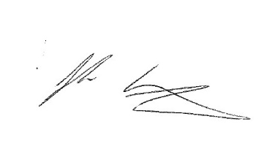

John King
Director
1st December 2025

